**Commodity Mega-Trades**

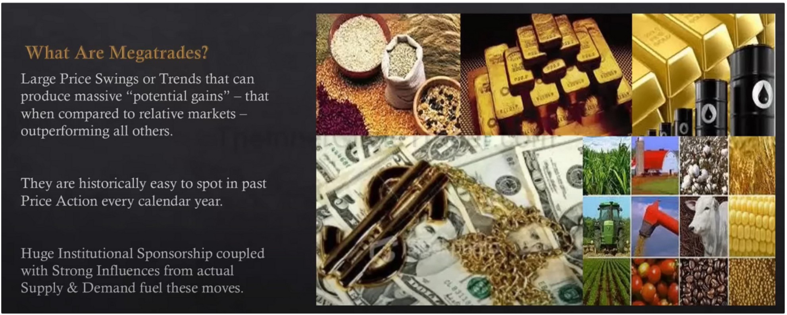

Supply and demand factors are an absolute reality when it comes to commodities

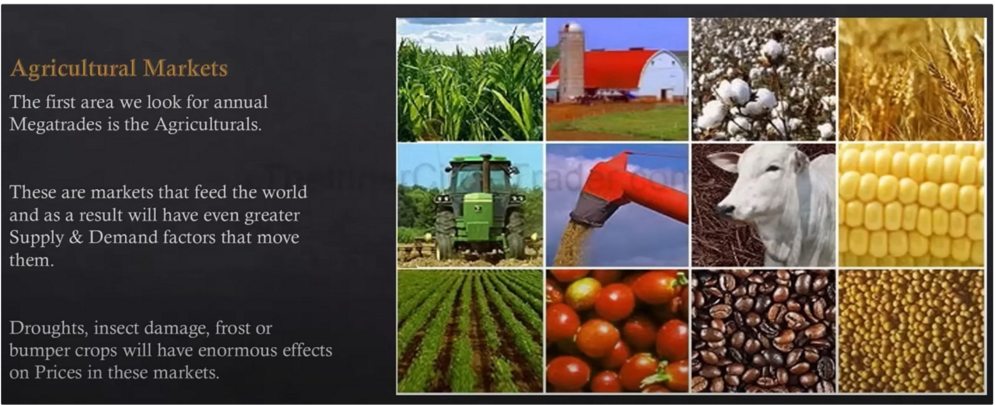

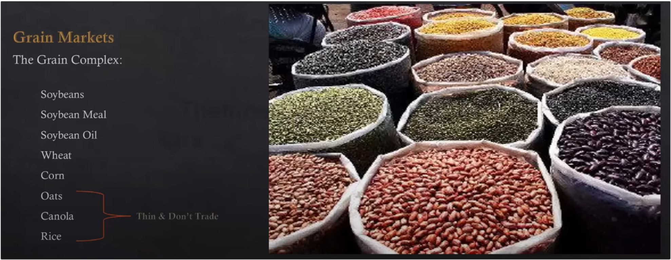

Mainly soybeans, wheat and corn.

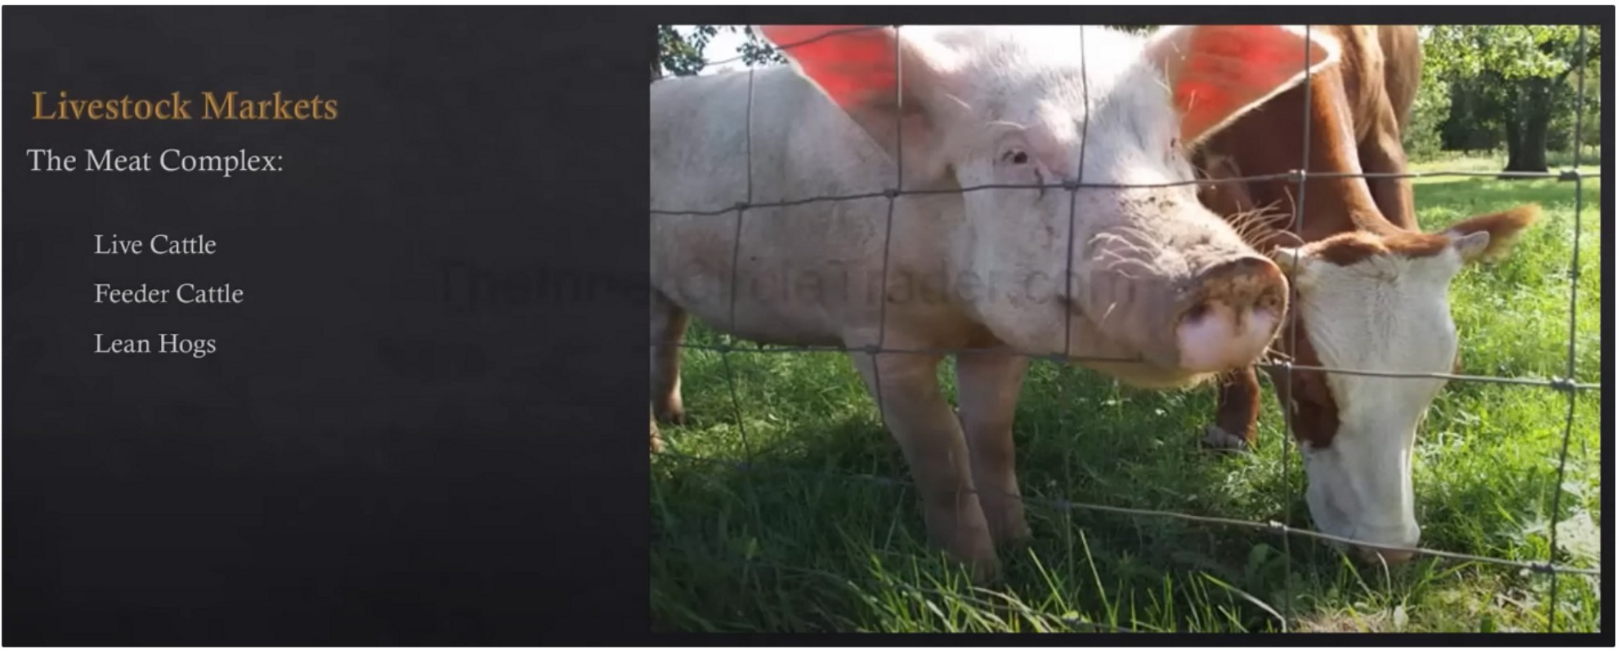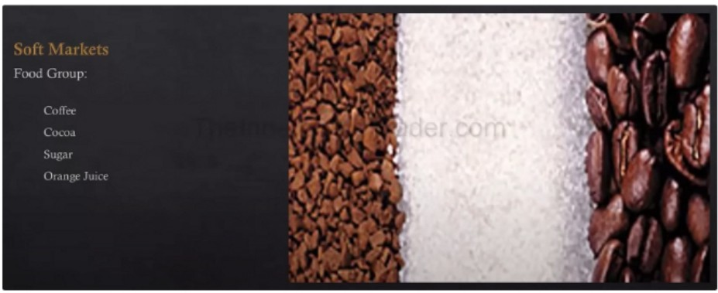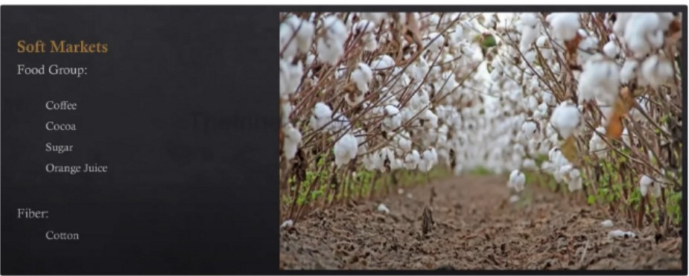

We look at 11 agriculture markets Next is fincancial markets

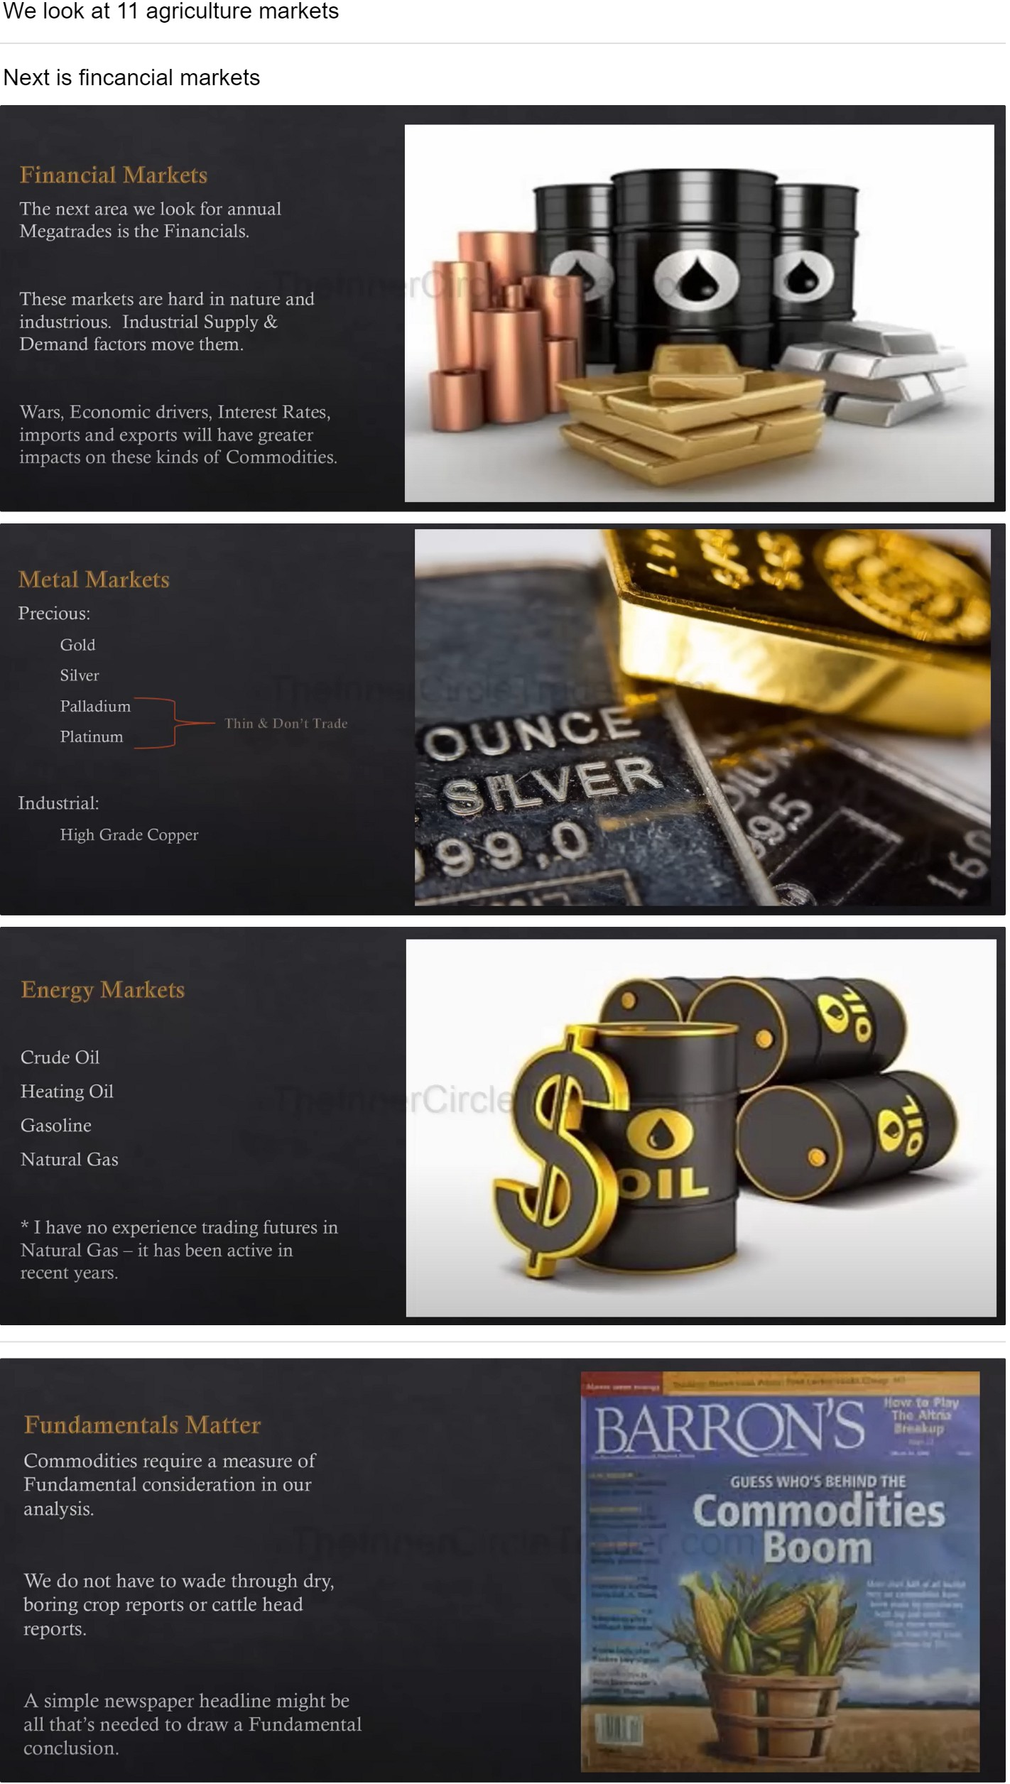

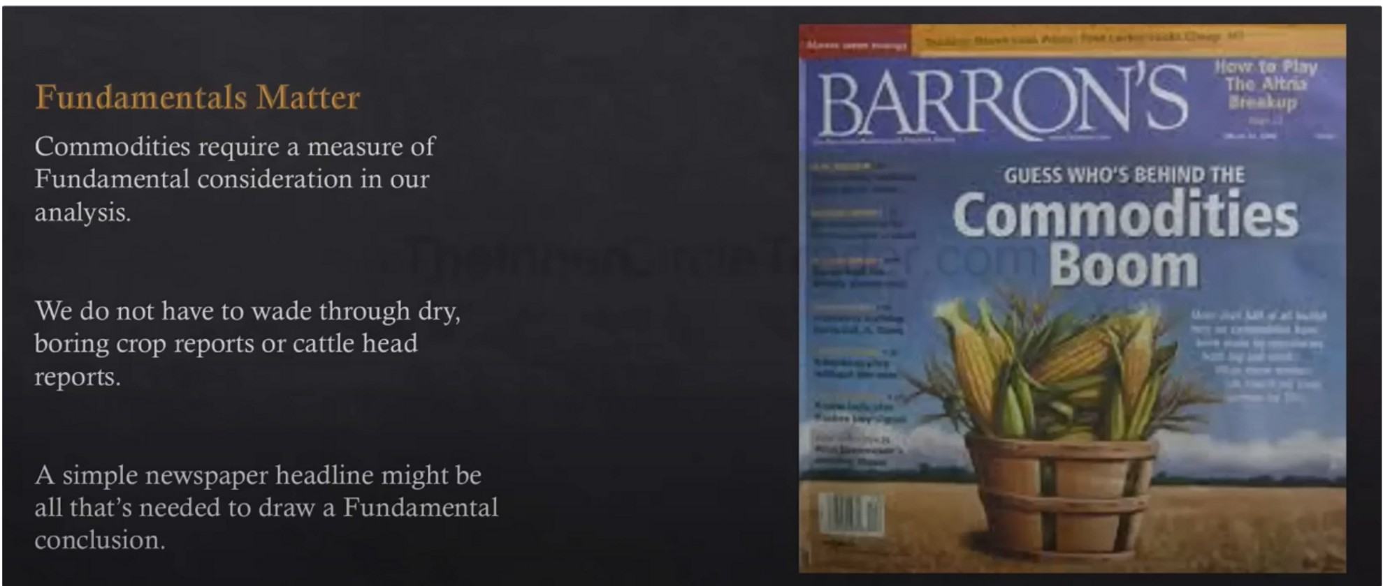

For example a parasite in the crops and its in the middle of the summer, it will ignite all kinds of buying

Commodities magazine, futures magazine have these sections with hot commodities and almost all of the time we can see theyve been moving for a while so generally those are due for a reversal, beautiful contrarians signals



**Soybeans Nov '17 (ZSX17)**

**1015·4S +16·2** ( **+1.63%)** 07/07/17 [CBOT]

**All FUTURES CONTRACTS** for Fn,Jul 7th, 2017

Set Alerts •watchlist

**lntraday**

**V Main Vi**

I 1111 l I .1 I 11 l I I I. I I ',I,II I I 11" I\ I j II I

A quick & easy first step is to consult the delivery month closing prices.

|  |  |  |  |
| --- | --- | --- | --- |
|  | **Contract** | **Last** | **Chang** |
| + | **ZSYOO (Cash)** | 969·4S | •15-0 |
| + | ZSN17 Ou! '17) | 996-0s | •15·2 |
| + | ZSQ17 (Aug '17) | 1001-0s | ·15·2 |
| + | ZSU17 (Sep '17) | **1006·2s** | ·15-4 |
| + | ZSX17 (Nov '17) | 101:,·4S | ·16·2 |
| + | ZSF18 Oan '18) | 1023•2s | •16·4 |
| + | ZSH18 (Mar '18) | 1018·6S | **•14-4** |
| + | ZSK18 **(May** '18) | 1021·2s | •14-4 |
| + | ZSN180ul '18) | 1027-4s | ·14-2 |
| + | ZSQ18 (Aug '18) | 1025-4s | ·14·0 |

Note if any commodity has a Premium over distant months out. This will be our Primary search every year - for explosive Hull l\farkets.

-'· \\'L' d() !l()t rl'qu1rl' .1 Prl'm1um t() hL'

Bull1sh c1 Cumn1lld!l, It ml'IL'h c1dds to thL' l1kl'l1h,Hi,l ,11 ,l "str,111_c:.. !'1 IL.L' l<..lih

You want to hold on to these parabolic moves, it can be scary at first but they tend to move further then you expect

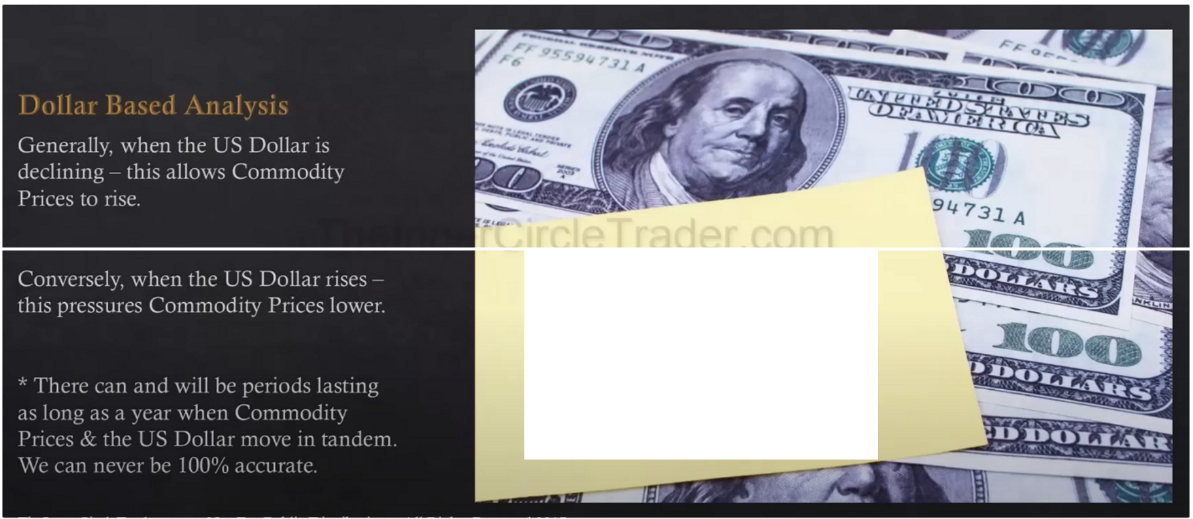

***CotnlflhdJJ,iRA,***

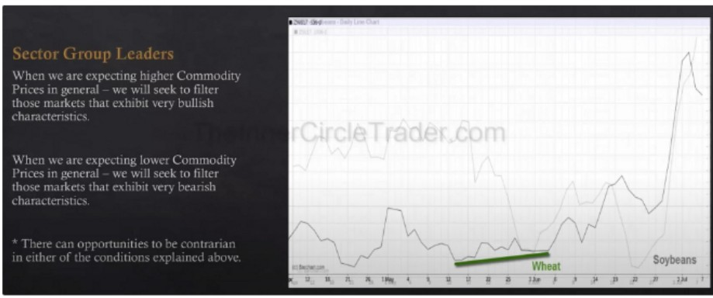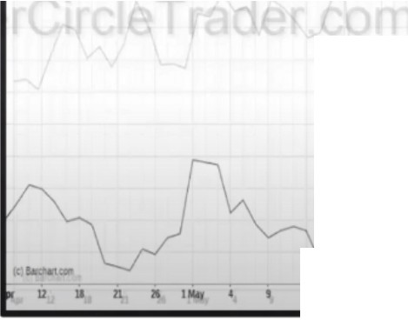

*�*

**Soybeauma** = **$4800 JPCll' oomract**

= $6500 pa OOllll.tnd

-

*J*

-

**Wheat**

**Soybeans**

**U U D JI** l,_

I **t 1' D ZJ**

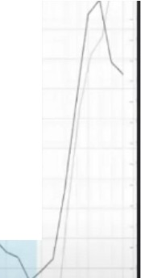Smart money accumulation in commodities while the dollar is going down We want to find the strongest of a specific commodity sector, the leader

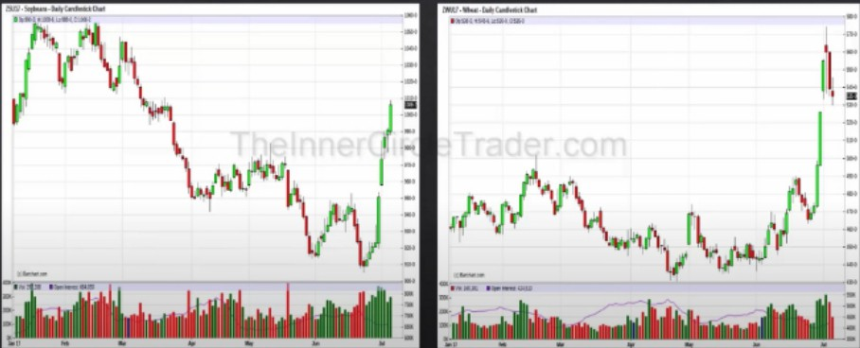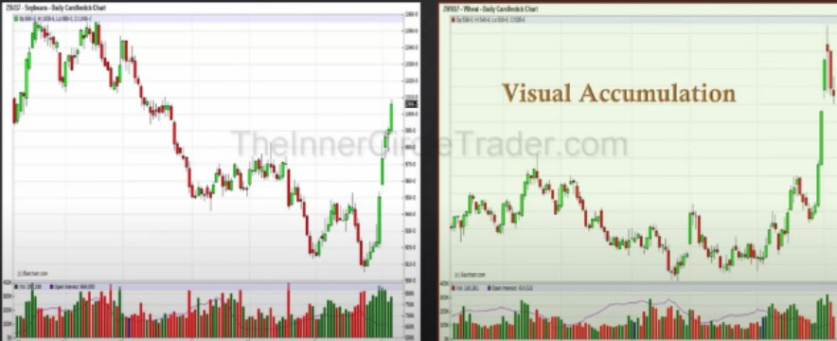

Also notice we had a massive decline in open interest in may while wheat was in a consolidation, then in june we saw another decline in open interest

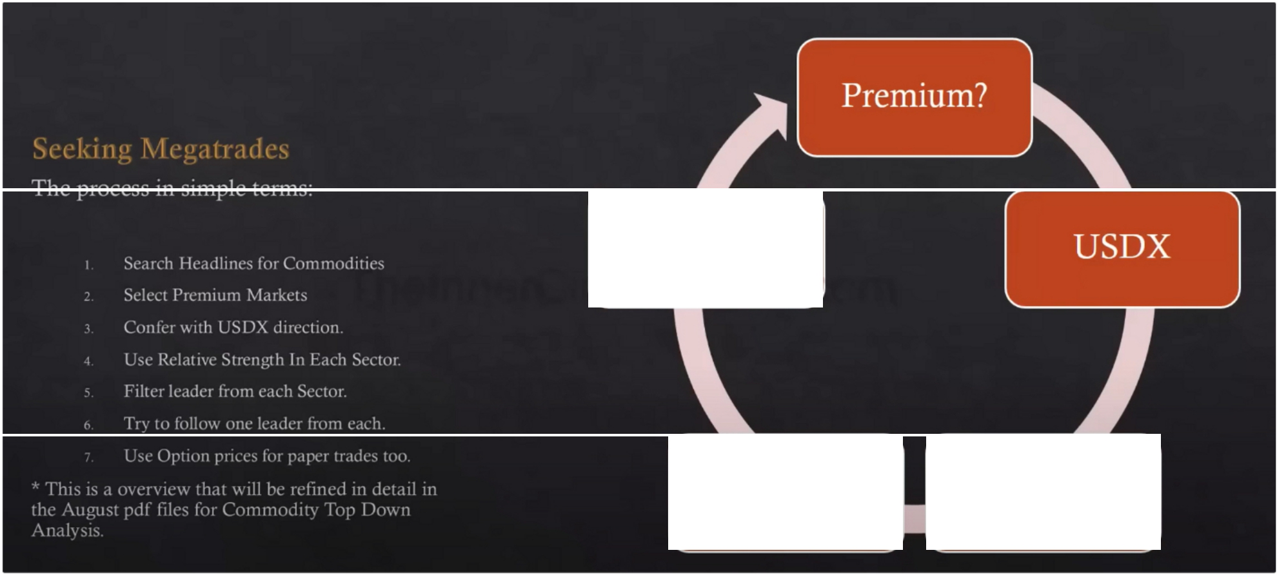

Diversify

In Sectors

Sector

Leader

Relative Strength

We dont need a market premium, but if it does we will focus on the premium markets Commodities up dollar down for ideal situation

4. relative strength is SMT

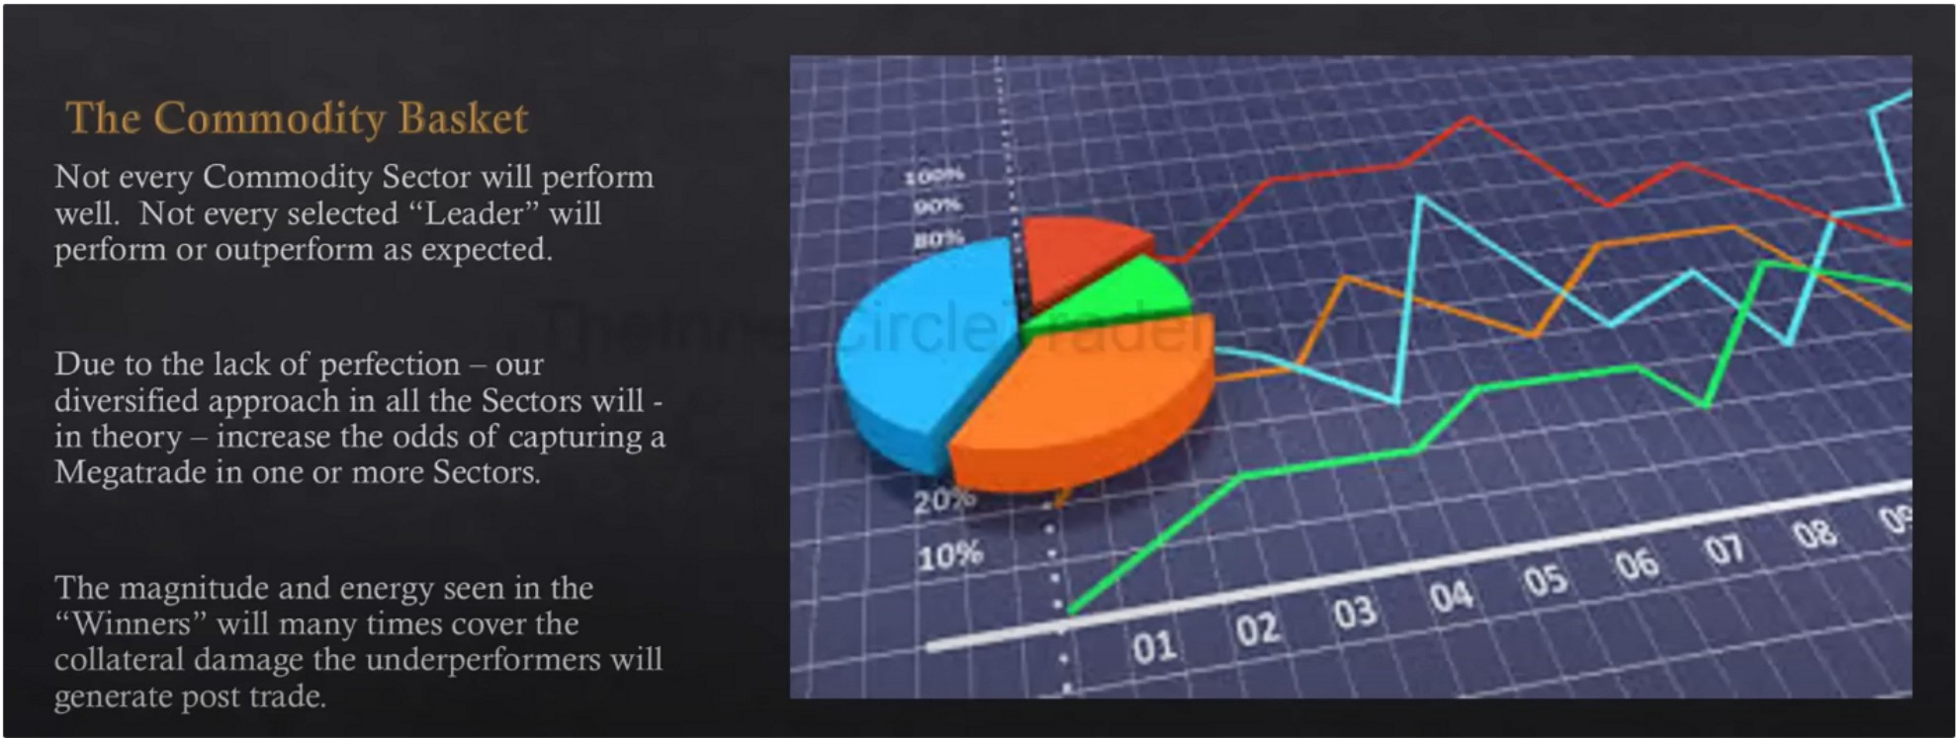

You can compare the leaders of each sector as well and see which one of those has more relative strength, for instance if were bullish: which one of the leaders is starting to break highs earlier then the others? And which one is seeing more support at downclosed candles? Then you can take more risk % on the strongest. The 8 leaders can be refined down to 3, so that you can mainly put your highest risk on the 3 and less risk on the other 5



If you turn it into a game it becomes fun



Currencies will also do these kind of things, bonds and stocks also.

This will build a greater understanding of the market and price action as a whole

Arjo I Twitter, lnstagram I Linktree

Linktree. Make your link do more. https://t.co/HhmmTN1fUI

JavaScript is not available.

*"!I* https://twitter.com/arjoio